EL3002-MICROPROCESSOR INTERFACING

Project Report



**Automatic control of street lights**

Submitted by:

|  |  |
| --- | --- |
| --------------  -------------- | Roll-Num  Roll-Num |

Submitted to:

-------------------

DATE

Department of Electrical Engineering

National University of Computer and Emerging Sciences, Lahore

## Introduction

1. **Problem Analysis**

## Design Requirements

1. **Feasibility Analysis**

## Possible Solutions

1. **Preliminary Design**

## Design Description

## Software Simulation

## Experimental Results

1. **Performance Analysis**
2. **Future Scope**

## Social and Cultural Implications

1. **Conclusion**

Automatic street light control is intended to automatically turn on and off street lights. This project measures the light output. Street lights are automatically turned off when there is 80% light availability. But this project will automatically switch on street lights if the amount of light is less than 80%. It may also be modified to suit an individual's needs. Light intensity is measured using a light sensor. The amount of light available is sensed using a light sensor connected to a PIC161F877A microcontroller. The pic16f877a microcontroller produces a control signal after analyzing the amount of light. The transistor, which in turn energizes the relay coil and the relay turns on the street light, is activated by a control signal provided by the pic microcontroller. Only one bulb was utilized in this project. Because this is only being done as an example. You may utilize as many street lights as you desire with this automated control of street lights to put it to practical use.

We were supposed make automatic control of street lights using the microcontroller. We will sensors, processor (PIC microcontroller), and a display device. We will also use an actuator (relays) to control specific attributes in our system. The system is expected to make use of interrupts and timers for delay and counting purpose. We will also use LCD display which is required for output messages.

One of the main problems we are going to face in this project will be converting the analogue values to digital. In addition to that we may face problems while interfacing the LCD.

Another problem that we may face is that whilst designing the project we must keep in mind that we have to implement the circuit within a limited budget so we need to be selective in choosing the right components.

Followings are the main components of automatic control of street lights:

Light sensor:

The amount of light is measured using a light sensor. Light dependent resistors (LDRs) are employed as light sensors even though there are many other types of light sensors on the market. Because it is inexpensive, easily accessible, and easily interfaced with microcontrollers to measure light intensity. LDRs have the ability to adjust their resistance in response to light intensity. LDR will have low resistance if light levels are high, and high resistance if light levels are low. Thus, using a formula from the data sheet, a microcontroller can readily read this resistance as voltage, which can then be translated back into a proportionate value of light. I advise you to glance at the LDR data sheet.

Relay interfacing with microcontroller:

As I have already mentioned above that microcontroller is used to analyze intensity of light and to generate control signal which in turn on or off transistor which in turn energize relay to turn street light on or off. NPN transistor is used as a switch and resistor at the base of transistor is used as current limiting resistor. Diode is used to avoid back emf voltage which may produce sparking across relay.

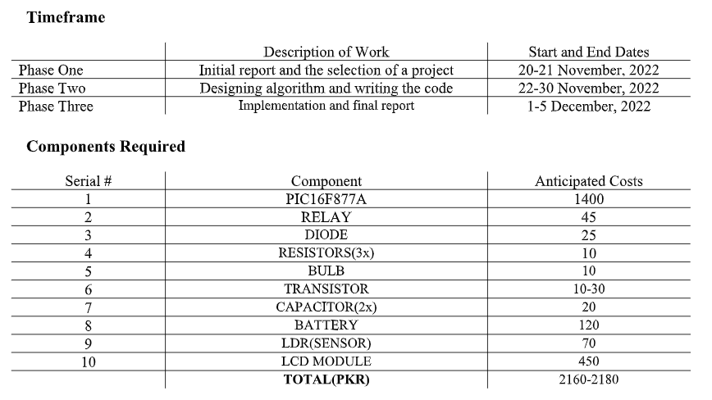

***Division of Work***

|  |  |  |
| --- | --- | --- |
|  | ------------- | ------------- |
| Initial Algorithm |  |  |
| Initial Design |  |  |
| Code |  |  |
| Proteus Design |  |  |
| Final Report |  |  |

Most of the problems were solved with the help of the Instructor which was further supported by the lab instructor. Whereas the problems related to design and the algorithm were solved by brain storming and a little bit help from the internet.

Relevant links have been provided at the end of the report

LCD

Street Light

Relay

Power Supply

Microcontroller

LDR

The main components used in this equipment are:

* *Pic Microcontroller (PIC16F877)*

The microcontroller that has been used for this system is from PIC series. PIC microcontroller is the first RISC based microcontroller fabricated in CMOS that uses separate bus for instruction and data allowing simultaneous access of program and data memory. Various microcontrollers offer different kinds of memories. EEPROM, EPROM, FLASH etc. are some of the memories of which FLASH is the most recently developed. Technology that is used in PIC16F887A is flash technology, so that data is retained even when the power is switched off.

* *Light-Emitting Diode (LED's)*

A Light Emitting Diode (LED) is a semiconductor device, which can emit light when an electric current passes through it. To do this, holes from p-type semiconductors recombine with electrons from n-type semiconductors to produce light.

* *Analogue to Digital Converter (ADC)*

Analog-to-Digital Converter (ADC) can convert an analog input signal to a 10-bit binary digital representation of that signal. The Microchip microcontroller’s analog inputs, which are multiplexed into a single sample and hold circuit. The output of the sample and hold is connected to the input of the ADC. The ADC generates the 10-bit binary result via successive approximation and stores the conversion result into the ADC result registers. The ADC uses a voltage reference that is software-selectable to be either internally generated or externally supplied.

* *Relay*

Relays are devices which allow low power circuits to switch a relatively high Current/Voltage ON/OFF. For a relay to operate a suitable pull-in & holding current should be passed through its coil. Relay is used in microcontrollers because relays are the link between the low power digital electronics and high-power devices. It allows digital circuits and digital microcontrollers to high power devices on and off. Simply, it is used to on/off power circuits using microcontrollers.

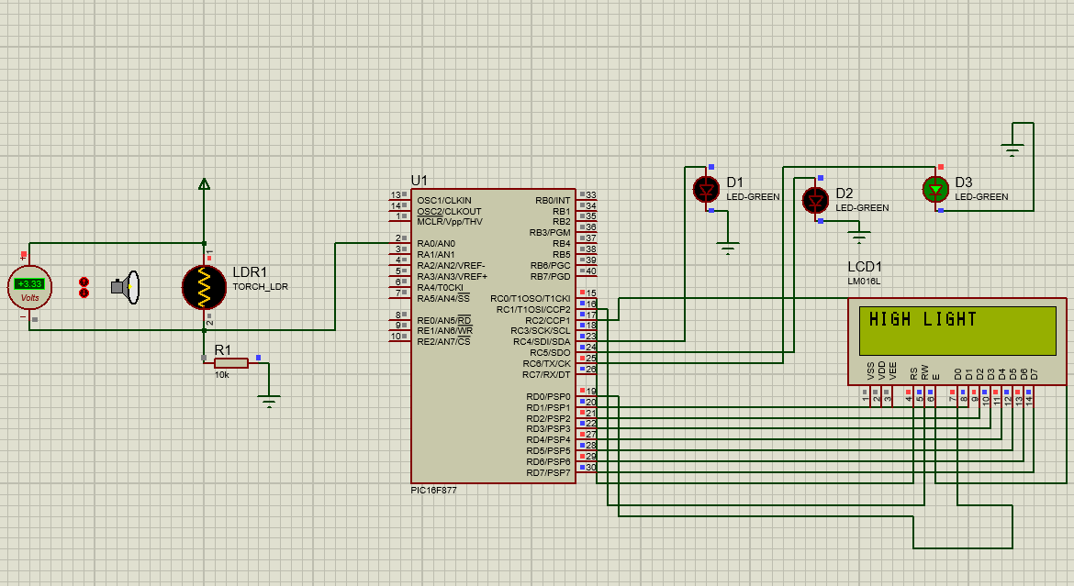

The performance of our project can be evaluated by looking at several criteria, including **efficiency, reliability, safety, cost, and ease of use.**

**Efficiency:** A microcontroller-based system should be able to sense the presence of traffic and pedestrians and turn the street lights on and off accordingly. This should help improve the efficiency of a street lighting system, as the lights will only be on when needed. (In our case we were not taking assessing the situation using traffic however we light were controlled in accordance to the light intensity)

**Reliability:** The microcontroller should be able to accurately detect changes in light levels and make the necessary adjustments in a timely manner. It should also be able to operate for long periods of time without experiencing any technical issues. (In our case the implemented code is reliable)

**Safety:** The system should be designed to prevent any accidents due to incorrect timing or incorrect light levels. The system should also be designed to be fail-safe, so that if any part of the system fails, the lights will remain on until repairs can be made.

**Cost:** The cost of the microcontroller will vary depending on the type of system being implemented. However, the overall cost of the system should be kept low to ensure that it is within the budget of the city. (Yes it is cost effective as we made in on a smaller scale only using PKR 2500)

**Ease of use:** The system should be designed to be user-friendly (In our case it is user friendly)

This project has a wide range of uses. For instance, you could be too sluggish to manually switch on or off your street light, so you neglect to do so every day. So you may easily utilize this idea to save money and electricity. In nations where load shedding is a major problem because there is a lack of power and resources to provide it. By making the most of your savings, you may help these nations' load shedding problems to some extent. The most energy may be saved by adopting automated street light control, which is advantageous for both you and your country. It will lower your power cost, saving you money.

The implications of automatic control of street lights are vast and varied. On a societal level, the use of automated street lights can lead to **improved safety, reduced energy consumption, and lower costs.**

**Improved safety:** Automated street lights can be programmed to turn on and off at specific times, ensuring that streets are well lit even when there is no pedestrian or vehicle traffic. This can reduce the likelihood of crime occurring as well as making it easier for drivers to see at night.

**Reduced energy consumption:** Automated street lights can be programmed to turn off when there is no traffic or pedestrian activity, reducing the amount of energy used to power the lights.

**Lower costs:** Automated street lights can be programmed to turn off when there is no traffic or pedestrian activity, reducing the amount of energy used to power the lights. This can lead to lower electricity bills for municipalities and businesses.

In addition, automated street lights can also be used to help **reduce light pollution**. This can help improve the **quality of the night sky**, making it easier for astronomers to observe the stars.

In conclusion, all objectives for our project were met, and all needed outcomes were produced. In this course, we were able to understand the fundamental and advanced functions of the PIC microcontroller via this project. This project was completed with assembly language. Utilizing Microcontrollers for the automated control of street lights is an efficient and cost-effective method for controlling street lights. It is simple to install and needs little upkeep, making it a great solution for a variety of applications. The system is able to detect changes in light intensity rapidly and precisely, and may inform users when a certain threshold is achieved. This system is also very user-friendly and can be customized to send users a number of personalized alerts. In addition, the microcontroller may be programmed to regulate the lights in a variety of ways, such as dimming them during off-peak hours or totally turning them off when there is no traffic. Lastly, the inclusion of a microcontroller facilitates system maintenance and modification for a variety of applications. Ultimately, the use of a microcontroller in street lighting management may give a cost-effective and efficient method for regulating street lights.

<https://classroom.google.com/u/1/c/NTI3MTk1Nzk1ODM3>

<https://www.eeweb.com/auto-intensity-control-of-street-lights-using-microcontroller/>

<https://www.youtube.com/watch?v=iSSTVUpGrsA>